**Time series**

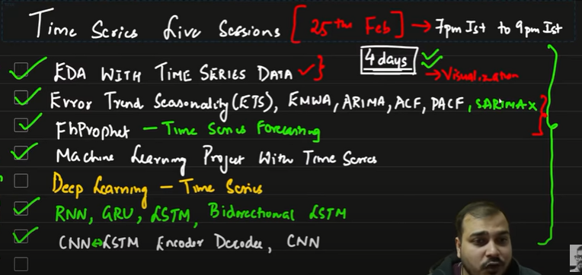

Time Series EDA 🡪

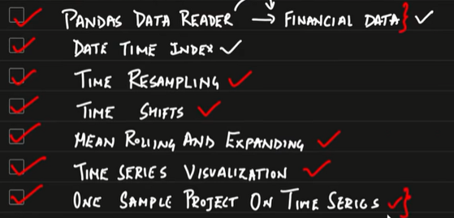

pandas datareader 🡪 help getting different datas